# **CI/CD Automation Tool Walk-through**

## Publishing Console Application as an Azure WebJob:

1. Open **‘CRM Solution Manager’** Solution in Visual Studio and provide values where keys are blank in **App.config** file. (Please don’t modify the keys where values are already present)
2. Build the solution
3. After Successful build, go to Solution Explorer and right click on ‘CRM Solution Manager’ Project and then click on **‘Publish as Azure WebJob’**:

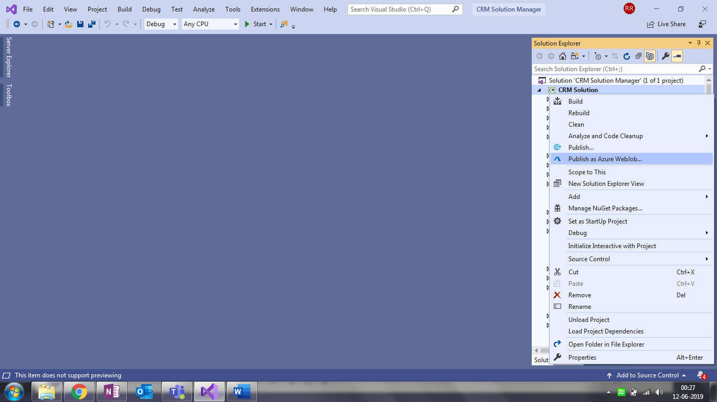

1. On the next screen, under **‘WebJob Name’**, give a name to the WebJob and select **‘WebJob run mode’** as **‘Run on Demand’** and click **OK** button:

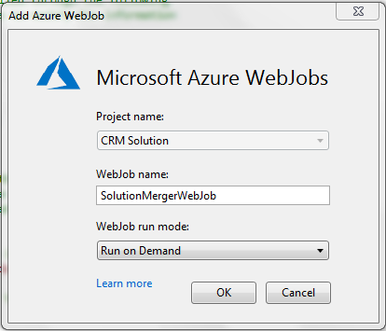

1. On the next screen, select **‘Create New’** and click on **‘Publish’**:

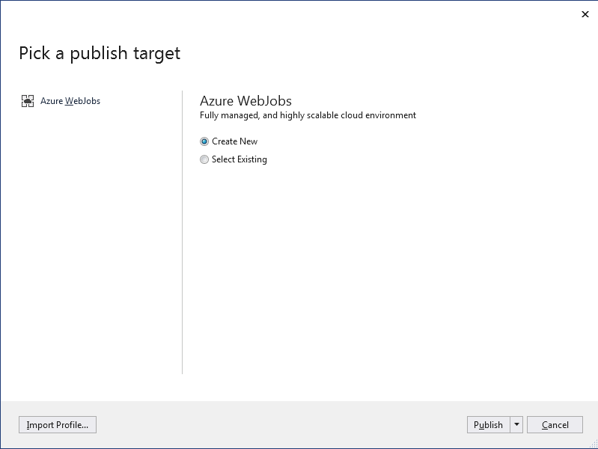

1. On the next screen, sign in to your azure portal by clicking on **Sign In** button:

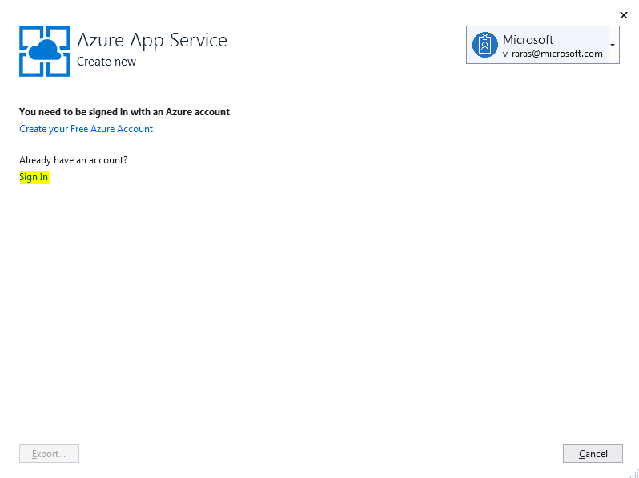

1. On the next screen, under **‘Name’**,give a name to the App Service, select **Subscription** As **‘Free Trial’**, select **Resource Group** for the App Service and click on **Create**:

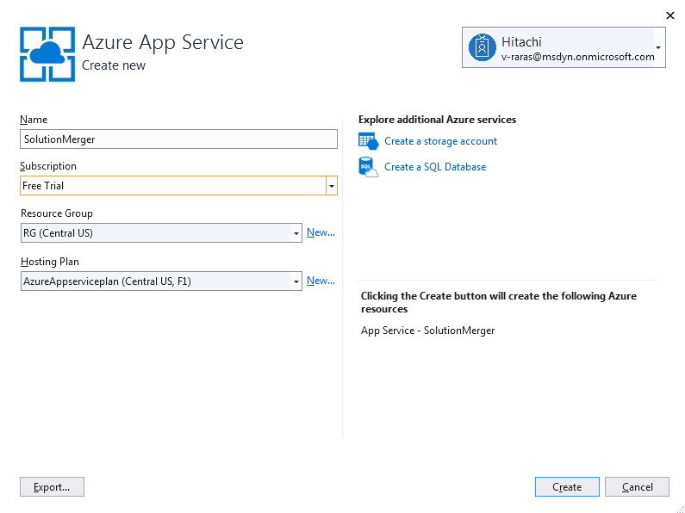

1. On the next screen, click on **Publish**:

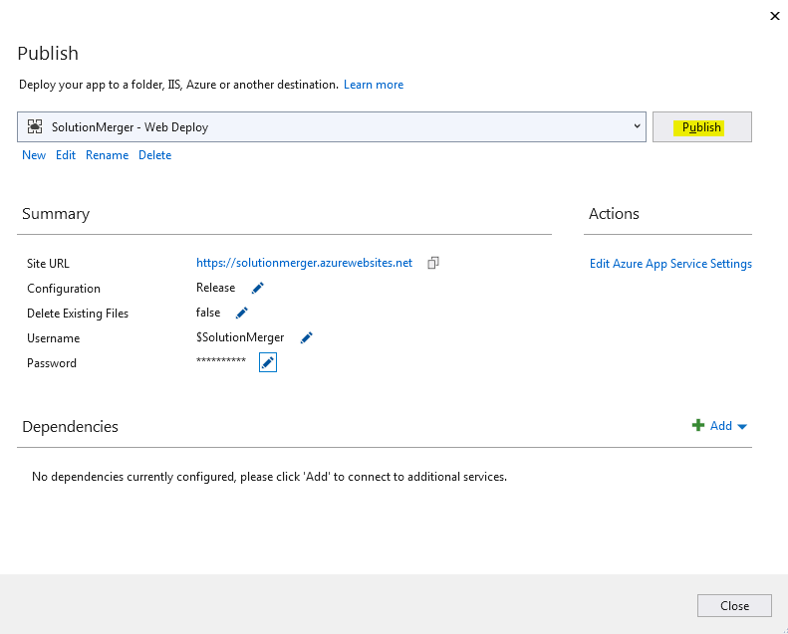

This will **Publish the WebJob** **(Web App)** in **Azure**. You can see the output message in **Output Window** in Visual Studio:

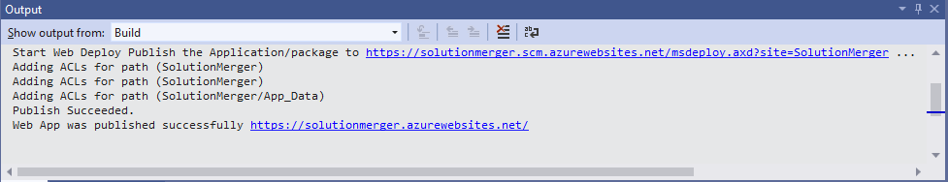

You can login to your Azure Portal and should be able to see your recently created **Webjob** under **App Services** tab:

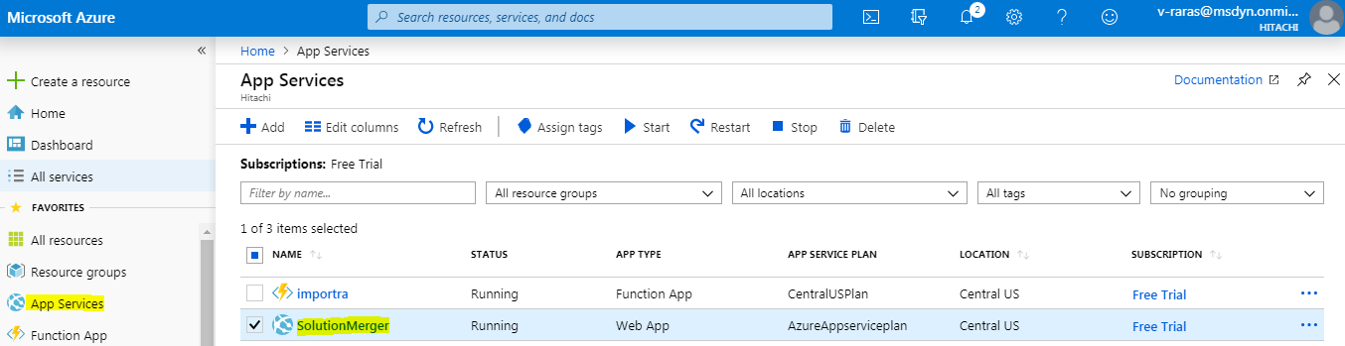

## Creating Flow to call Azure WebJob:

1. Go to [https://india.flow.microsoft.com](https://india.flow.microsoft.com/) and login to flow using CRM credentials where **DevOps** solution is installed.
2. Next, Click on **My Flows** tab under left pane, click on **New** and select **Automated-from blank**.
3. On the next screen, under **Flow Name**, give a name to your flow, under **Choose your flow’s trigger**, select **When a record is updated** and then click **Create**:

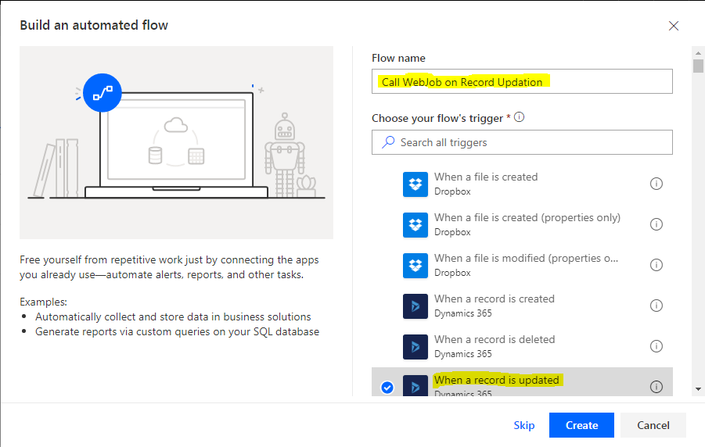

1. On the next screen, under **Organization Name**, select your organization from the drop down, under **Entity Name**, select **Dynamics Source Control** from the drop down and click **New Step**:

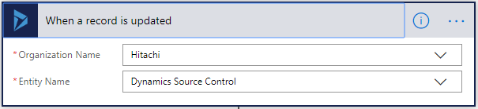

1. On the next screen, under **Actions,** select **Condition:**

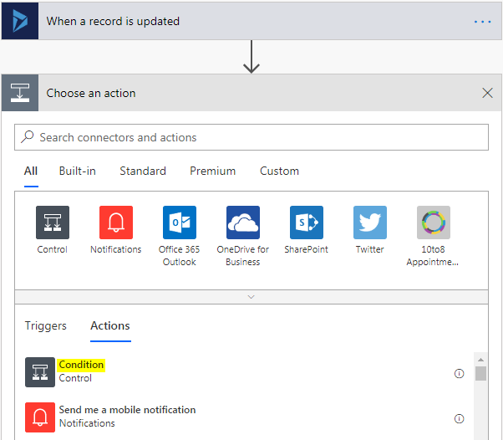

1. On the next screen, specify condition **Queue Status is equal to Queued** as given below and in **If Yes** step, click on **Add an action**:

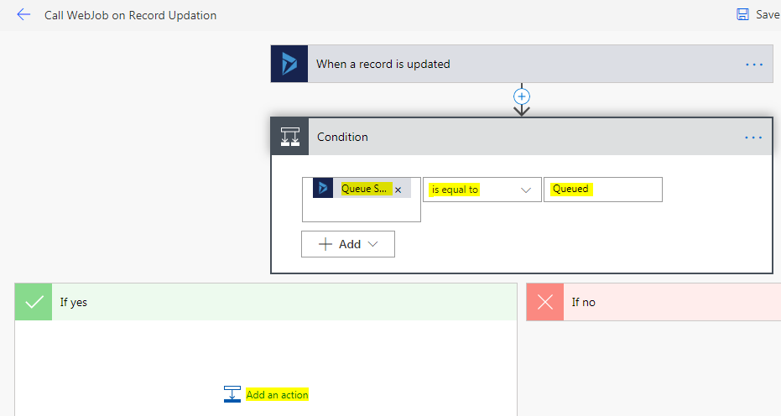

1. On the next, screen, under **Actions,** search http and select **HTTP** Action:

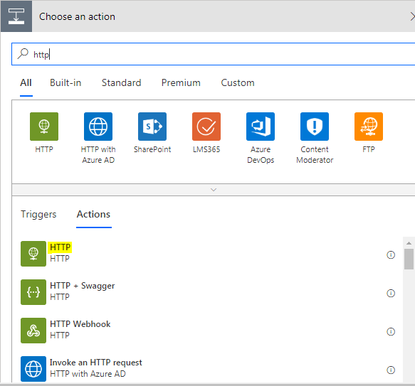

1. Choose **Method** as **POST**, under **Uri**, **Azure WebJob WEB HOOK** needs to be provided. You don’t need to set **Headers, Queries** and **Body**. Under **Advanced Options**, Choose **Authentication** as **Basic** and the **Username** and **Password** also need to be provided from **Azure WebJob** only. (Steps to get Azure WebJob WEB HOOK*, Username* and Password* are provided at the last)

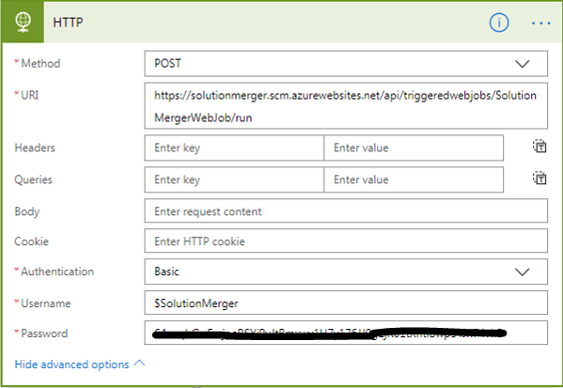

1. Next, click on **Save.** This will create the flow which will call our **Azure Webjob** when condition is satisfied.

**Steps To get Azure WebJob Uri, Username and Password:**

1. Login to Azure portal: [https://portal.azure.com](https://portal.azure.com/)
2. Click on your **Webjob** under **App Services** tab:



1. On the next screen, scroll down the middle pane, click on **Webjobs.** Now select the WebJob and click on **Properties:**

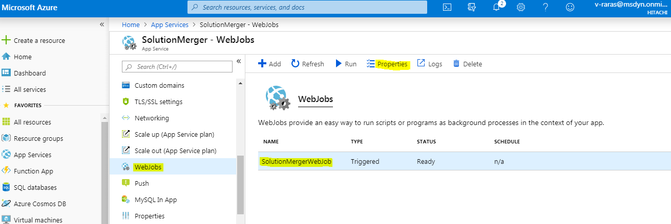

1. A new window will open up at right, from where you can copy **WEB HOOK, Username and Password:**

